*Prompt 1 — Create the basic lab application*
Create a simple educational web application for an undergraduate AIML laboratory.
Title:
Discrete Probability Distributions
The application will eventually contain:
1. Binomial Distribution
2. Poisson Distribution
3. Geometric Distribution
For now, implement only the basic application structure and the Binomial Distribution module.
Keep the UI simple and clean. Do not add unnecessary features.
Create a navigation/header with:
- Home
- Binomial
- Poisson
- Geometric
Only the Binomial page needs to be functional at this stage.
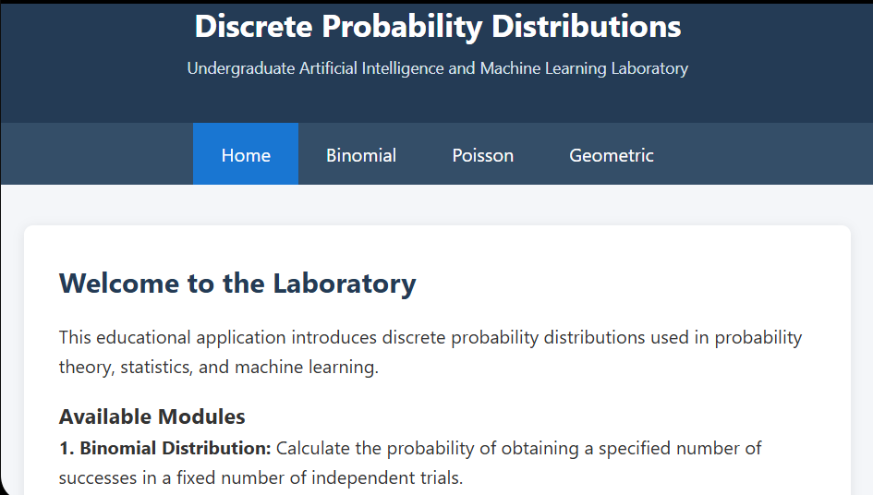
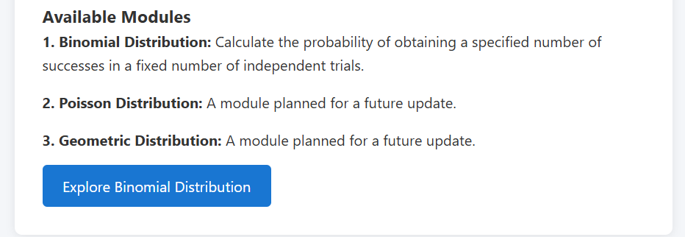

*Binomial Distribution*
*Prompt 2 — Add Binomial inputs*
Implement the Binomial Distribution section.
Add two input controls:
- Number of trials n
- Probability of success p
Set default values:
n = 20
p = 0.35
Validate the inputs:
- n must be a positive integer
- p must be between 0 and 1
Display the selected values clearly.
Do not add simulation yet. 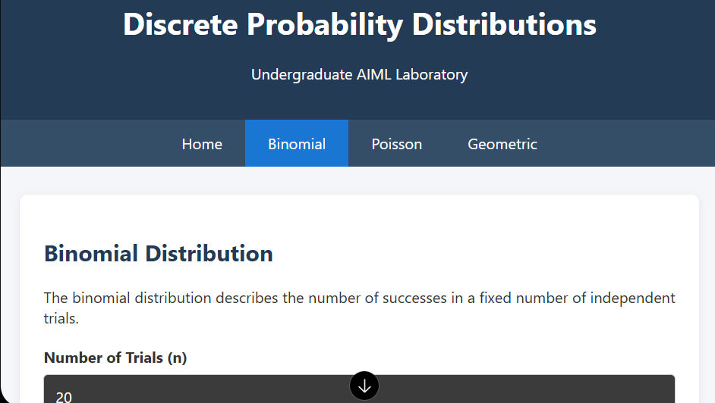
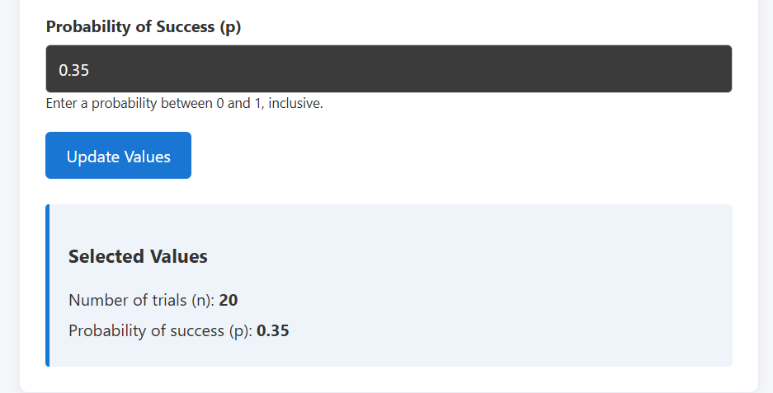

*Prompt 3 — Calculate Binomial statistics*
Add the Binomial probability calculations using the selected n and p.
Calculate and display:
- Mean
- Variance
- Standard deviation
- Second moment E[X²]
- Skewness
Use the following formulas:
Mean:
np
Variance:
np(1-p)
Second moment:
Variance + Mean²
Skewness:
(1-2p) / sqrt(np(1-p))
Display the results in simple statistic cards.
For the default values n=20 and p=0.35, verify that the mean is 7 and variance is 4.55.
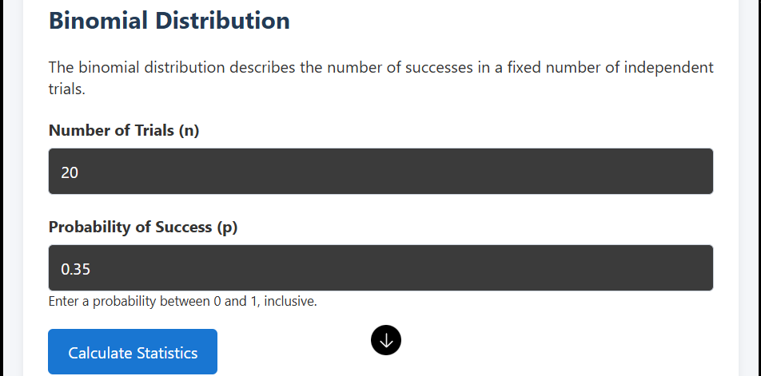
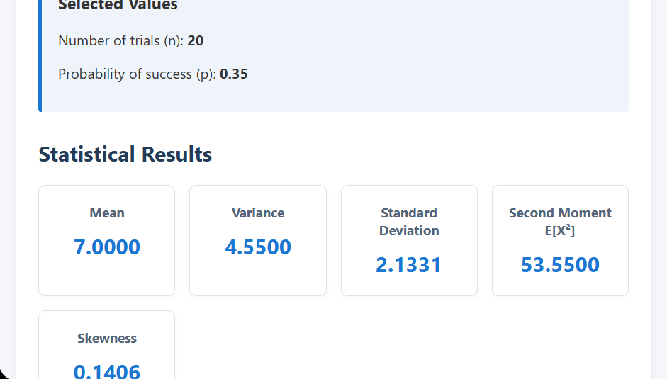
*Prompt 4 — Add PMF*
Add a Binomial PMF calculator.
For:
X ~ Binomial(n,p)
calculate:
P(X = k)
Allow the student to enter k.
Validate that:
0 <= k <= n
Display the probability clearly.
Also display the mathematical expression:
P(X=k) = C(n,k) p^k (1-p)^(n-k)
Explain in one simple sentence what the result means.
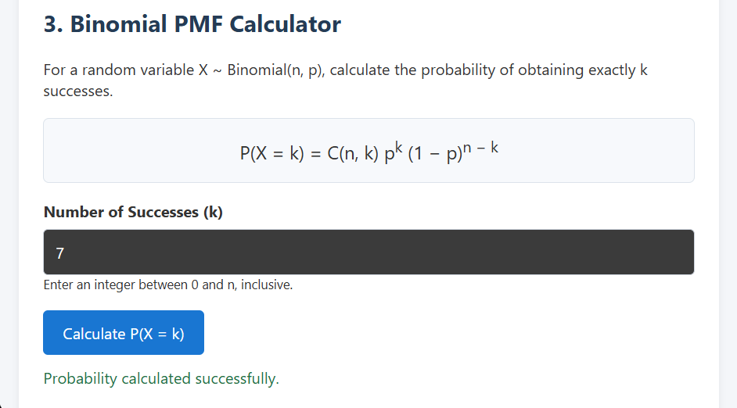
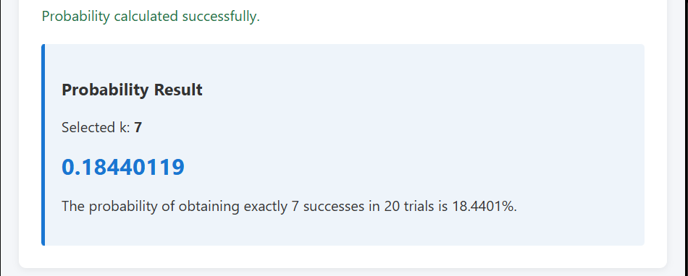

*Prompt 5 — Add CDF*
Add a Binomial CDF calculator.
Allow the student to enter k.
Calculate:
P(X <= k)
Also calculate:
P(X > k) = 1 - P(X <= k)
Display both results.
Explain:
“P(X <= k) means the probability of getting k or fewer successes.”HTML code
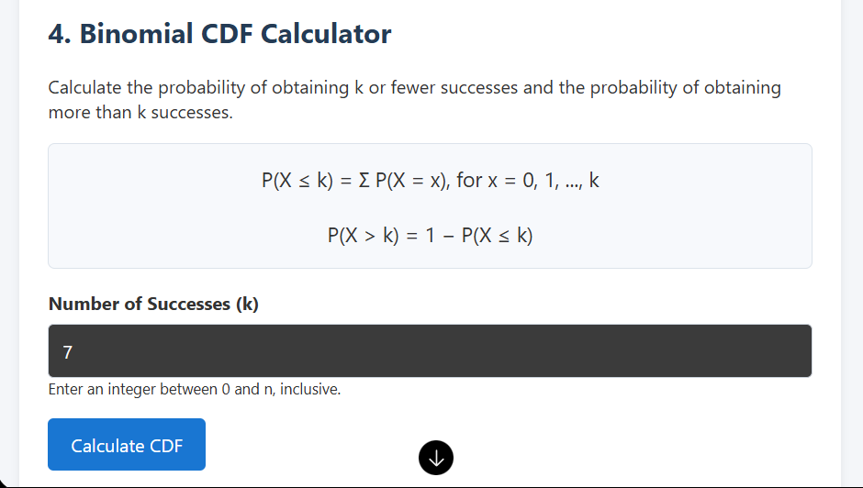
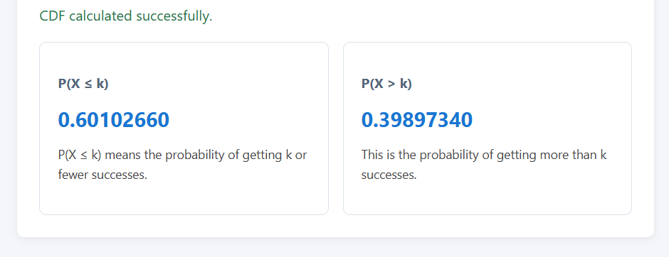
*Prompt 6 — Add Binomial PMF graph*
Add a bar chart showing the Binomial PMF.
X-axis:
Number of successes X
Y-axis:
Probability P(X)
Plot values for:
X = 0, 1, 2, ..., n
Use the current values of n and p.
Add a vertical dashed reference line at the mean.
Add a tooltip showing:
X = value
P(X=value) = probability
Update the graph automatically whenever n or p changes.

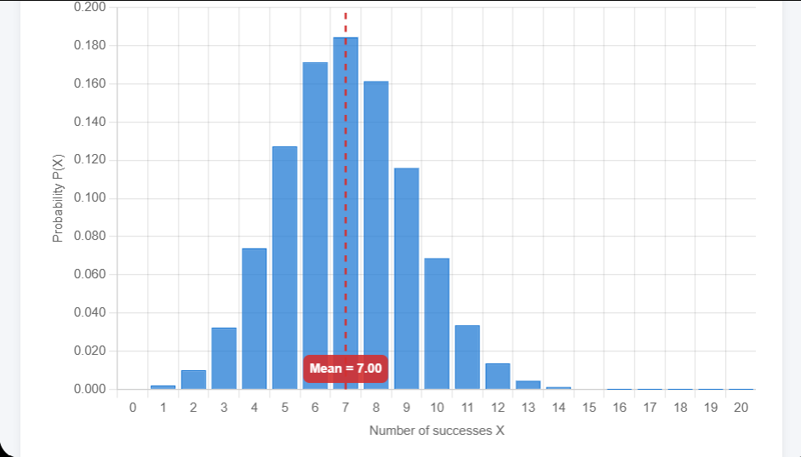

Prompt 7:
Add a Poisson Distribution module to my existing “Discrete Probability Distributions”
HTML application.
Keep the existing Binomial module fully functional.
Keep the same navigation, design, cards, buttons, and responsive layout.
Add Poisson to the navigation bar.
Set the default rate parameter to λ = 4.
λ must be greater than 0. Display an error message for invalid inputs.
Add Input Parameters, Statistics, PMF Calculation, CDF Calculation, and a PMF bar
chart.
Calculate Mean = λ, Variance = λ, and Standard Deviation = √λ.
Use PMF: P(X=k) = (e⁻λ × λᵏ) / k!, where k is a non-negative integer.
Use CDF: P(X≤k) = Σ P(X=i), for i = 0 to k.
Also calculate P(X>k) = 1 − P(X≤k).
Set the default value of k to 4.
Display the results in cards matching the existing Binomial module.
Use darkblue bars and a vertical dashed red line at the mean in the graph.
When λ changes and the Update button is clicked, automatically update the statistics
and graph.
Validate inputs and display appropriate error messages.
Write the actual HTML, CSS, and JavaScript in my existing file. Do not create a
separate application or change the existing Binomial module.
Return the complete updated HTML file.
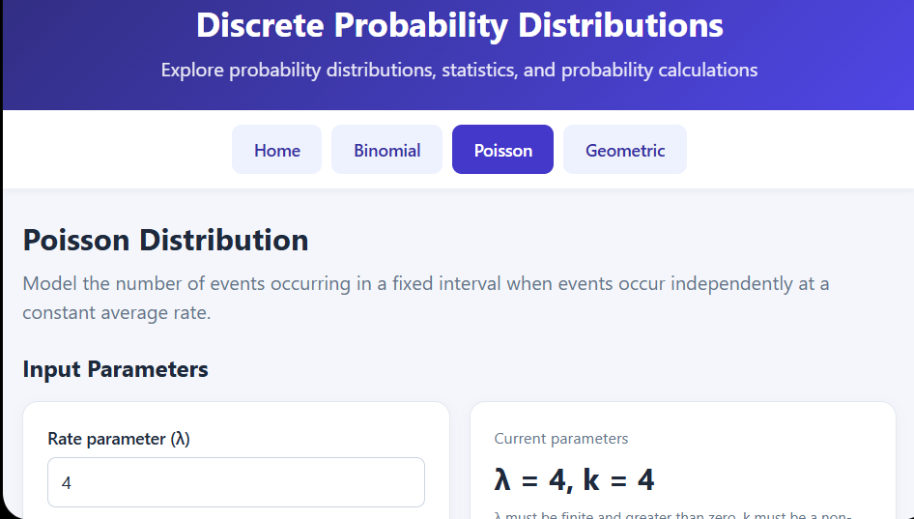

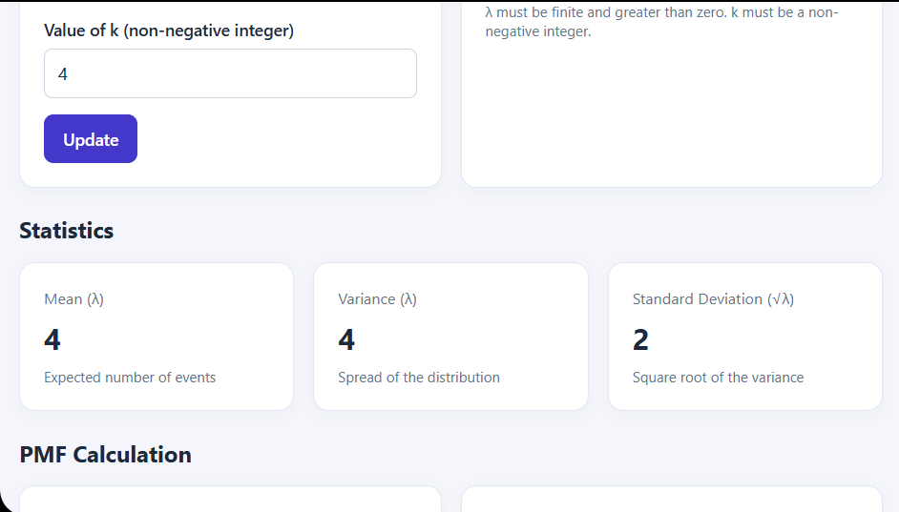
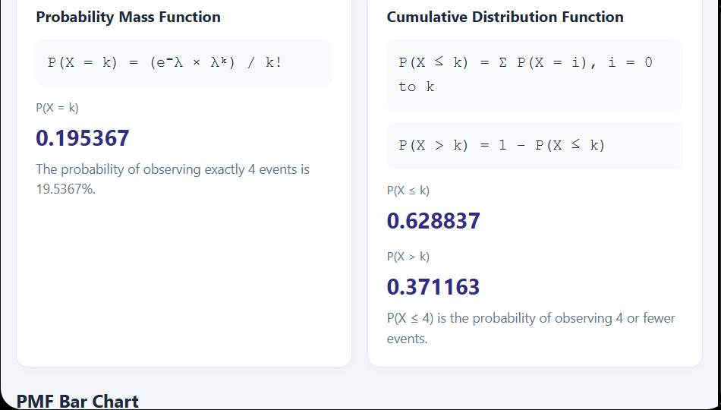
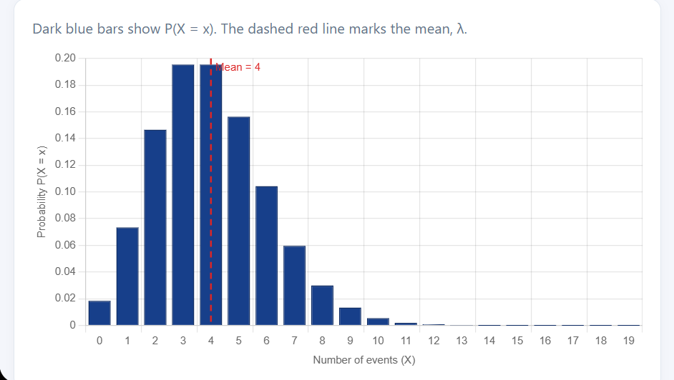

Prompt 8:
Add a Geometric Distribution module to my existing “Discrete Probability Distributions”
HTML application.
Keep the existing Binomial and Poisson modules fully functional.
Keep the same navigation, design, cards, buttons, and responsive layout.
Add Geometric to the navigation bar.
Set the default probability of success to p = 0.35.
Use the convention X = trial number of the first success, starting from 1.
Add Input Parameters, Statistics, PMF Calculation, CDF Calculation, and a PMF bar
chart.
Calculate Mean = 1/p, Variance = (1-p)/p², and Standard Deviation = √(1-p)/p.
Use PMF: P(X=k) = (1-p)^(k-1) × p.
Use CDF: P(X≤k) = 1-(1-p)^k.
Validate inputs and display error messages.
Use orange bars and a vertical dashed red line at the mean in the graph.
Write the actual HTML, CSS, and JavaScript in my existing file. Do not create a
separate application or change the existing modules.
Return the complete updated HTML file.
